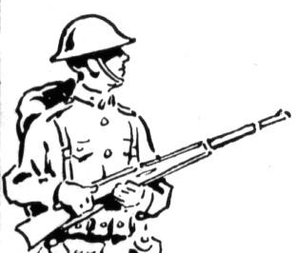
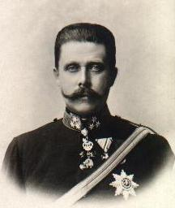

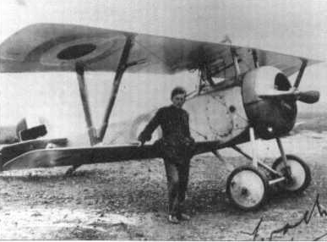
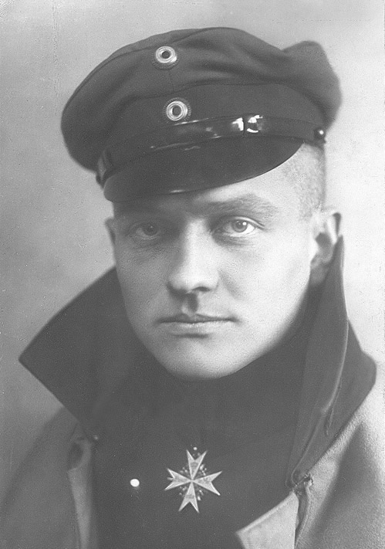
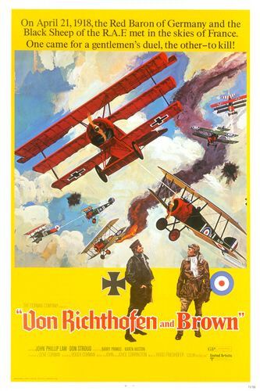
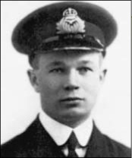
Billy Bishop
Fighter Pilots
Manfred von Richthofen
Roy Brown
The Red Baron

Snoopy VS The Red Baron – Royal Guardsman

After the turn of the century
In the clear blue skies over Germany
Came a roar and a thunder men had never heard
Like the scream and the sound of a big war bird
Up in the sky, a man in a plane
Baron von Richtofin was his name
Eighty men tried, and eighty men died
Now they're buried together on the countryside
Chorus:
Ten, twenty, thirty, forty, fifty or more
The Bloody Red Baron was rollin' out the score
Eighty men died tryin' to end that spree
Of the Bloody Red Baron of Germany
In the nick of time, a hero arose
A funny-looking dog with a big black nose
He flew into the sky to seek revenge
But the Baron shot him down--"Curses, foiled again!"
(chorus)
Now, Snoopy had sworn that he'd get that man
So he asked the Great Pumpkin for a new battle plan
He challenged the German to a real dogfight
While the Baron was laughing, he got him in his sight
That Bloody Red Baron was in a fix
He'd tried everything, but he'd run out of tricks
Snoopy fired once, and he fired twice
And that Bloody Red Baron went spinning out of sight

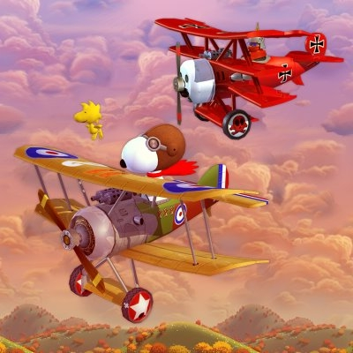

ROY BROWN AND WOP MAY – JOHN SPEARN
"It's the Baron!" in terror they cried.
Eighty men tried him. Eighty men died.
With the German Flying Circus along for the ride
Nothing seemed likely to turn the tide.
CHORUS: Through the haze flew Roy Brown and Wop May,
Two Royal Air Force fly boys from Canadi-ay.
"Stop the Flying Circus!" they'd toast.
"Down with the Baron!" they'd drink to their host.
There was fear in the sky when the Red Baron did fly,
For numb was his nerve, and firm his despise.
Eighty small emblems appeared as his brand,
Each an opponent, shot down by his hand.
For Manfred was a sniper who wore no disguise.
From a fortress in Breslau came bullets with eyes.
From above, he'd swoop out of the sun.
On the doomed Allied pilot he'd open his guns! CHORUS
'Twas in spring of '18, over Amiens one day,
On his maiden mission, the rookie Wop May
Felt the roar of a tri-plane hurtling his way.
There were death lights flashing! He veered from the fray
And a free-fall.., he tried to escape but in vain,
For the Baron was right on his heels again.
And he prayed, "Take me home, Lord. I'm finished, I fear."
When high from the sky, Captain Brown did appear!
And with guns ablaze, from above and below,
The Great Baron's plane became lifeless and slow.
And it fluttered and fell to the ground
Where the great ace, Von Richtofen, dying was found.
