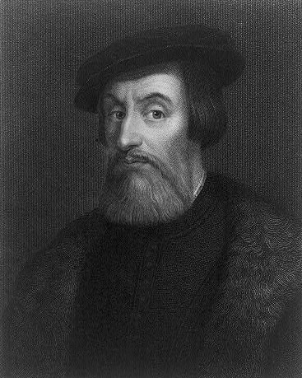

The following is the legacy of Hernan Cortes as described by www.wikipedia.org:
Hernán(do) Cortés, Marqués del Valle de Oaxaca (1485–December 2, 1547) was the conquistador who conquered the Aztec empire. Cortés was part of the generation that established the Spanish Empire in the Americas.
It is extremely difficult to characterize this particular conquistador – his unspeakable atrocities, his tactical and strategic awareness, the rewards for his Tlaxcalteca allies along with the rehabilitation of the nobility (including a castle for Moctezuma II's heirs in Spain that still stands), his respect for Indians as worthy adversaries and family members.
His dealings with the Native Americans were almost always honorable. Cortes sought to pacify, not provoke; to appease with gifts, not oppress with guns. He hoped to acquire a productive province, not a slave state. Orders to his troops were explicit. No one was to "vex or offend" the natives. Women and children must always be spared. Only food, and that scrupulously paid for, might be taken. Looting and rape were punishable by death.
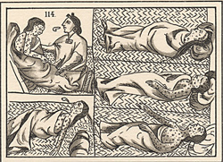
It must be remembered that Cortes's small army, however brave, could never have prevailed against hundreds of thousands of hostile foes. Only in the first few battles were they without allies. Cortes's policy of friendship allowed him to use the internal dissensions of the Aztec Empire to destroy it. In so doing, he made himself the champion of the vast majority of the Indians of New Spain. He was their friend and protector, and he never lost their love and respect.
Smallpox, introduced by Europeans, devastated the Aztec population. It killed most of the Aztec army, the emperor, and 25% of the overall population. A Spanish priest left this description: “As the Indians did not know the remedy of the disease…they died in heaps, like bedbugs. In many places it happened that everyone in a house died and, as it was impossible to bury the great number of dead, they pulled down the houses over them so that their homes become their tombs.” On Cortés’ return, he found the Aztec army’s chain of command in ruins. The soldiers who lived were still weak from the disease. Cortés then easily defeated the Aztecs and entered Tenochtitlán, where he found that smallpox had killed more Aztecs than had the cannons. The Spaniards said that they could not walk through the streets without stepping on the bodies of smallpox victims.
Cortes hoped to avoid the errors that had been made in the Islands. His letters to Charles V are filled with warnings and pleas. He begged that only settlers be allowed in New Spain, not adventurers "intent on consuming the country's substance and then abandoning it." He asked for humble priests who would convert by pious example, not high prelates who would "dispose of the gifts of the Church and waste them in pomp and other vices." Despite (or because of?) the fact that he had studied law, he recommended that lawyers be banned on the grounds that they encouraged contention in order to profit from the ensuing litigation. Most of all, he deplored the practice of repaying services to the Crown with Indian slaves to work land grants. Yet he had no other way of rewarding his own followers.
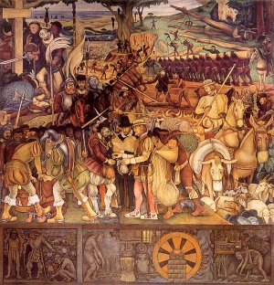
Charles V was not interested. He obviously believed his insistence on the conversion of the natives, thus ensuring their Heavenly reward, was quite enough and considered enslavement a small price to pay for such favors. Nor did he accede to any other request. The troublesome Cortes was soon replaced with a governing committee which exiled him.
Cortes' fall from grace was a black-letter day for the natives and they knew it. Had he chosen defiance, Gómara claims, "almost all the Spanish and all the Indians would have taken up arms in his favor and defense." When Cortes returned from Honduras after having been reported dead he found his lands confiscated, his treasury looted and his home occupied by enemies. The Indians greeted him with wild rejoicing and his fellow Spaniards were willing to join him in ousting the usurpers.
Instead, Cortes meekly sailed for Spain, hoping to clear his name with the Emperor. He succeeded and was fobbed off with a title and huge land grants, complete with thousands of slaves. He was graciously allowed to retain the office of Captain General and continue his profitable conquests for the Crown, but denied any say in their administration. Cortes was forced to watch as men like Nuño de Guzmán destroyed all he had hoped to build.
The way Indians were treated varied from one part of the Americas to another. However, they were generally treated better in the Kingdom of New Spain than in Peru. With great vision, Hernán Cortés tried to preserve the monuments of the Aztecs and funded the construction of schools and hospitals out of his own pocket, providing for them in his will.
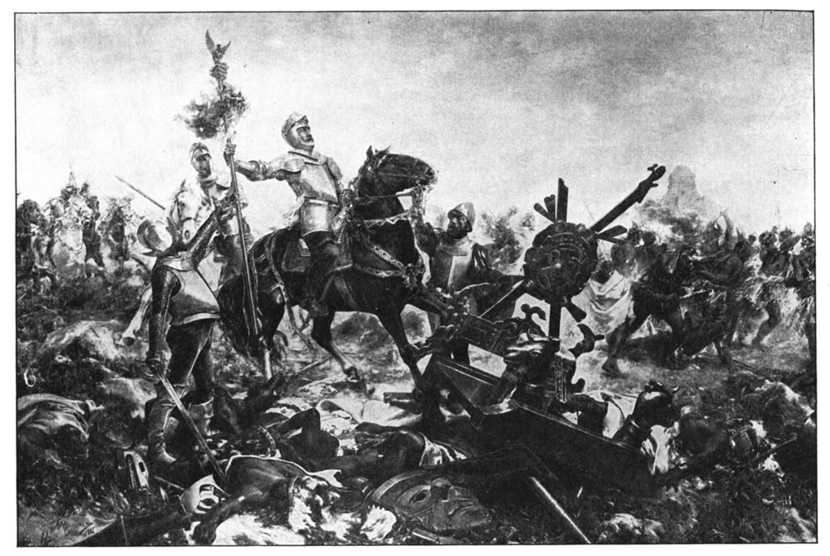
In the process of conquest Cortés successfully identified the complexities of local indigenous politics, especially the animosity felt by many native groups towards the Mexica-Aztec Empire. This tactic was one which Cortés had experienced and adopted from earlier conquests in the Caribbean. However, the use of terror and the capturing of native leaders reappear over and over in Spanish conquest history and were not unique inventions of Cortés. His attempt to justify his conquest of the Mexican mainland — a right held by the Governor of Cuba Diego Velasquez — through the founding of Veracruz and an appeal directly to Emperor Charles V had been used by other conquistadors interested in usurping the right of conquest.
It must be remembered that when Velasquez conquered Cuba he did so with the authority of the Governor of Santo Domingo Diego Columbus. But when he established the city of Santiago, he formed a town council with which he resigned his offices from Columbus and established him as governor of Cuba under the Spanish Crown. The Crown gave him the legal authority once it recognized the fait accompli. It was a precedent that Velasquez would subsequently come to regret.

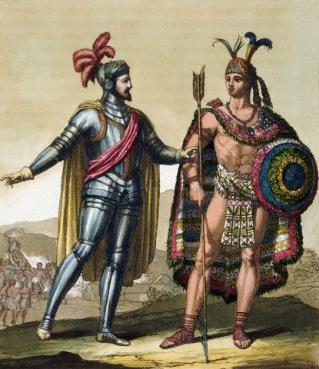
The song is about Hernán Cortés, a conquistador who conquered Mexico for Spain in the 1500s. The song also makes reference to the Aztec ruler Moctezuma II and other events that occurred in the Spanish conquest of the New World. Young has stated in concert that he wrote the song while studying history in high school.
In the liner notes for Decade, Neil writes that the song is banned in Spain. In Spain, Hernando Cortez (or Hernán Cortés) is considered a national hero.
In Mexico, Cortez is viewed less favorably. In the early 1500's, Cortez had an army of 600 sail from what is now Cuba to the Aztec nation where he was considered to be a god. Cortez took their leader -- Emperor Montezuma -- as hostage and then killed many of the Aztecs. He also unwittingly brought new diseases to the Americas, which the natives had no immunities towards. He built what is now Mexico City with slave labor

Cortez The Killer by Neil Young
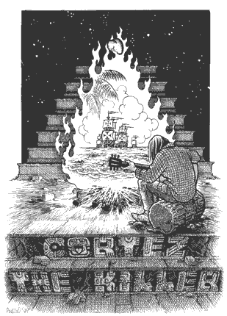
He came dancing across the water
With his galleons and guns
Looking for the new world
In that palace in the sun.
On the shore lay Montezuma
With his coca leaves and pearls
In his halls he often wondered
With the secrets of the worlds.
And his subjects gathered 'round him
Like the leaves around a tree
In their clothes of many colors
For the angry gods to see.
And the women all were beautiful
And the men stood straight and strong
They offered life in sacrifice
So that others could go on.
Hate was just a legend
And war was never known
The people worked together
And they lifted many stones.
They carried them to the flatlands
And they died along the way
But they built up with their bare hands
What we still can't do today.
And I know she's living there
And she loves me to this day
I still can't remember when
Or how I lost my way.
He came dancing across the water
Cortez, Cortez
What a killer
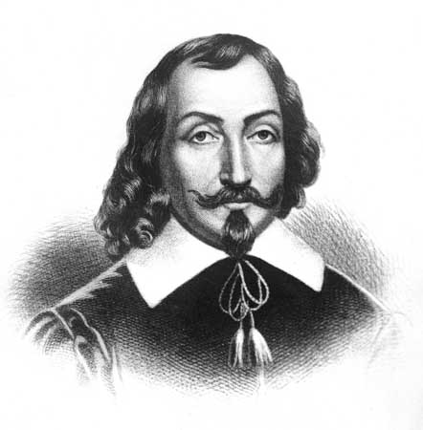

The following is the legacy of Samuel de Champlain as described by www.wikipedia.org:
Samuel de Champlain , the "father of New France," was born between 1567 and 1570 in the town of Brouage, a seaport on France's west coast and died in 1635 in Québec. A sailor, he also came to be respected as a talented navigator, mapmaker, and founder of Quebec City. He was also integral in opening North America up to French trade, especially the fur trade. Champlain's pattern was to spend several months or years exploring North America and then to head back to France to raise more funds for further explorations.
He arrived on his first trip to North America on March 15, 1603, a member of a fur-trading expedition. Although he had no official assignment on the voyage, he created a map of the St. Lawrence River.
In the spring of 1608, three ships left the French port of Honfleur, one of them the Don-de-Dieu commanded by Champlain. In June, the small group of settlers arrived at Tadoussac. There, they left the ships and continued to Québec in small boats. On July 3, 1608, Champlain landed at the "point of Quebec" and set about fortifying the area. At Quebec he erected houses, sowed grain, and did all he could to develop the fur trade, and in a short time the settlement began to grow. This was to become the city of Quebec. Fortifying Quebec City became one of his passions, which he embarked on periodically for the rest of his life. The first winter was difficult for the colonists. Of the twenty-eight people who stayed for the winter only eight survived, most having died of scurvy, some of smallpox and some of the extremely cold weather.
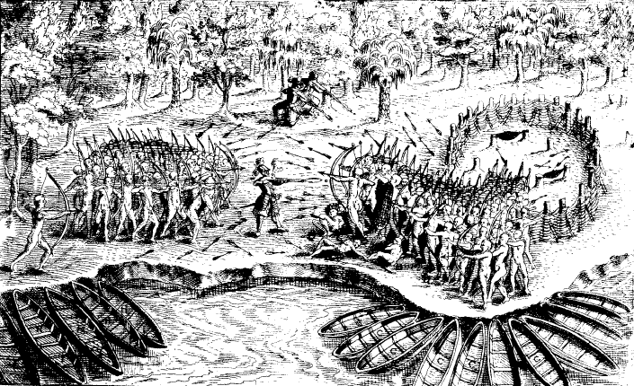
During the summer of 1609, having become friendly with the Montagnais, an Indian tribe on the St. Lawrence, and who demanded that Champlain helped them in their war against the Iroquois, who were much more to the south.he joined them in an expedition against the Iroquois. While in pursuance of this project, they were met by a party of Algonquins and Hurons, and, accompanied by them, ascended Sore river until they arrived at the Chambly rapids. Having at this point sent back his boat and crew, Champlain proceeded in a canoe, and entering a lake, gave it his own name. Having had no encounters with the Iroquois, at this point many of the men headed back, leaving Champlain with only 2 Frenchmen and 60 natives.
Champlain and his Indians met a large force of the Iroquois on the lake. Both parties landed and threw up barricades of trees. On the following day they engaged in battle, which resulted in the defeat of the hostile Indians. This result was largely due to Champlain. When he fired his rifle, he killed 2 Iroquois, and mortally wounded another. The Iroquois turned and fled. This was to set the tone for French-Iroquois relations for the next one hundred years.
After this expedition, he returned to France in an unsuccessful attempt, with the Sieur de Monts, to renew their fur trade monopoly. They did, however, form a society with some Rouen merchants, in which Quebec would become an exclusive warehouse for their fur trade and, in return, the Rouen merchants would support the settlement. Champlain returned to Quebec on April 8, 1610. During the summer of 1611, he traveled to the area which is now Montreal where he cleared the land and built a wall "to see how it would last during the winter." Then, in order to increase his prestige among the natives, he shot the Lachine Rapids with them, a feat that had been done only once before by a European.
That fall he returned again to France to secure a future for his venture in the New World. Having lost the support of the merchants in 1610, he wrote a note to king Louis XIII to ask him to intervene on his behalf. On October 8, 1612, Louis XIII named Charles de Bourbon, comte de Soissons his lieutenant-general in New France. Soissons died almost immediately, and was succeeded in the office by Henry II, Prince of Condé. Champlain was given the title of lieutenant and received the power to exercise command in the lieutenant-general's name, to appoint "such captains and lieutenants as shall be expedient," to "commission officers for administration of justice and maintenance of police authority, regulations and ordinances," to make treaties and carry out wars with the natives, and to restrain merchants who did not belong to the society. His duties included finding the easiest way to China and the Indies, as well as to find and exploit mines of precious metals in the area.
On March 29, 1613, he arrived back in New France and proclaimed his new royal commission. Champlain set out on May 27 to continue his exploration of the Huron country and in hopes of finding the "northern sea" he had heard about (probably Hudson Bay). He traveled the Ottawa River, later giving the first description of this area. It was in June that he met with Tessouat, the Algonquin chief of Allumette Island, and offered to build the tribe a fort if they were to move from the area they occupied, with its poor soil, to the locality of the Lachine Rapids.
He returned to New France in the spring of 1615 with four Recollects priests in order to further religious life in the new colony. The Roman Catholic Church would be given en seigneurie large and valuable tracts of land estimated at nearly 30% of all the lands granted by the French Crown in New France.
Champlain continued to work to improve relations with the natives promising to help them in their struggles against the Iroquois. With his native guides he explored further up the Ottawa River and reached Lake Nipissing. He then followed the French River until he reached the fresh-water sea he called Lac Attigouautau (now Lake Huron).
On September 1, at Cahiagué (on Lake Simcoe), he started a military expedition. The party passed Lake Ontario at its eastern tip where they hid their canoes and continued their journey by land. Soon afterward, on territory now included in the state of New York, he attacked a town held by a tribe belonging to the Iroquois league. Pressured by the Hurons to attack prematurely, the assault failed. Champlain was wounded twice in the leg by arrows, one in his knee. The attack lasted three hours until they were forced to flee. Although he didn't want to, the Hurons insisted that Champlain spend the winter with them. During his stay he set off with them in their great deer hunt, during which he became lost and was forced to wander for three days living off game and sleeping under trees until he met up with a band of Indians by chance. He spent the rest of the winter learning "their country, their manners, customs, modes of life". On May 22, 1616, he left the Huron country and was back in Quebec on July 11 before heading back to France on July 20.
By October of 1635, Champlain was stricken with paralysis and stroke. He died childless on December 25, 1635. He was buried temporarily in an unmarked grave while construction was finished on the chapel of Monsieur le Gouverneur. Unfortunately, it was destroyed by fire in 1640 and immediately rebuilt but nothing is known of it after 1640, although after 1674 it no longer existed. As such the exact burial site of Champlain is unknown. However, Jesuit records tell us he died in the hands of his friend Charles Lallemant who also heard his last confession, a reassuring point for a Catholic of the period.
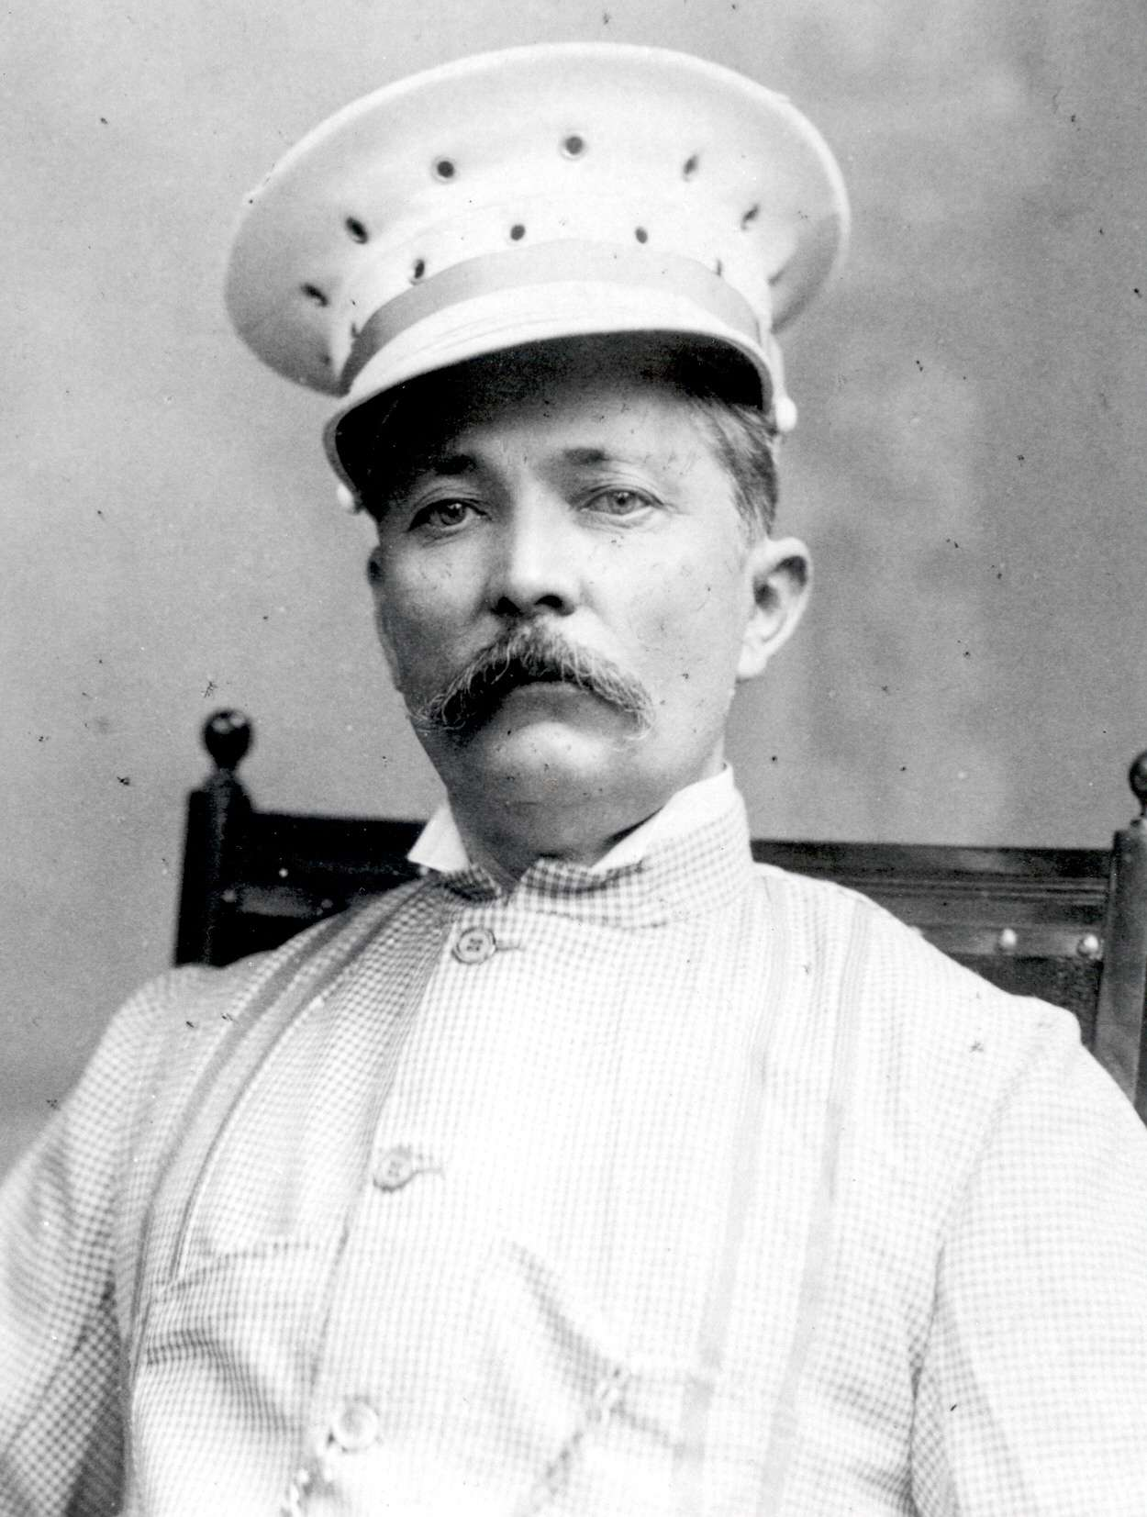

The following is the legacy of Henry Morton Stanley as described by www.wikipedia.org:

Sir Henry Morton Stanley, also known as Bula Matari (Breaker of Rocks) in Congo, born John Rowlands (1841-01-28 – 1904-05-10), was a 19th-century Welsh-born journalist and explorer famous for his exploration of Africa and his search for David Livingstone.
He was born in Denbigh, Denbighshire, Wales. His parents were not married, his father died when he was two years old and his mother, a butcher's daughter, refused to look after him, and he was brought up in a workhouse (now HM Stanley Hospital, St Asaph) until the age of 15. After completing an elementary education, he was employed as a pupil teacher in a National School. In 1859, at the age of 18, he made his passage to the United States on a ship, and upon arriving in New Orleans, he became friendly with a wealthy trader named Stanley, whose name he later assumed.
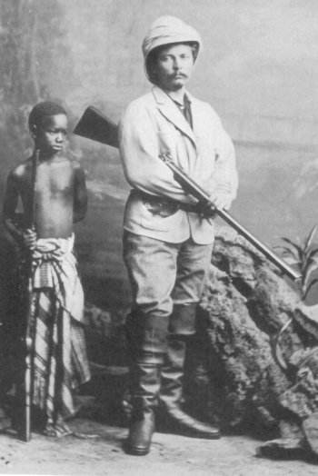
After military service with both sides in the American Civil War, Stanley was recruited in 1867 by Colonel Samuel Forster Tappan (a one-time journalist) of the Indian Peace Commission to serve as a correspondent to cover the work of the Commission for several newspapers. Stanley was soon retained exclusively by James Gordon Bennett (1795-1872), founder of the New York Herald. This early period of his professional life is described in Volume I of his book My Early Travels and Adventures in America and Asia (1895). He became one of the Herald's overseas correspondents and, in 1869, was instructed by Bennett's son to find the Scottish missionary and explorer David Livingstone, who was known to be in Africa but had not been heard from for some time. According to Stanley's no doubt romanticised account, he asked James Gordon Bennett, Jr. (1841-1918), who had succeeded to the paper's management at his father's retirement in 1867, how much he could spend. The reply was "Draw £1,000 now, and when you have gone through that, draw another £1,000, and when that is spent, draw another £1,000, and when you have finished that, draw another £1,000, and so on — BUT FIND LIVINGSTONE!""
Stanley traveled to Zanzibar and outfitted an expedition with the best of everything, requiring no less than 200 porters. He located Livingstone on November 10, 1871, in Ujiji near Lake Tanganyika in present-day Tanzania, and famously greeted him (at least according to his own journal) by saying "Dr. Livingstone, I presume?" (which was tongue-in-cheek because Livingstone was the only white person for hundreds of miles). Stanley joined him in exploring the region, establishing for certain that there was no connection between Lake Tanganyika and the river Nile. On his return, he wrote a book about his experiences. The New-York Herald, in partnership with Britain's Daily Telegraph, then financed him on another expedition to the African continent, one of his achievements being to solve the last great mystery of African exploration by tracing the course of the river Congo to the sea.
Controversy followed Stanley for most of his life. In later years he spent much energy defending himself against charges that his African expeditions had been marked by callous violence and brutality. Despite Stanley's efforts, the facts gradually emerged: his opinion was that "the savage only respects force, power, boldness, and decision." Stanley would eventually be held responsible for a number of deaths and was indirectly responsible for helping establish the rule of Léopold II of Belgium over the Congo Free State.
In 1886, Stanley led the Emin Pasha Relief Expedition to "rescue" Emin Pasha, the governor of Equatoria in the southern Sudan. After immense hardships and great loss of life, Stanley met Emin in 1888, discovered the Ruwenzori Range and Lake Edward, and emerged from the interior with Emin and his surviving followers at the end of 1890.
On his return to Europe, he married Welsh artist Dorothy Tennant, and entered Parliament as Unionist member for the London Borough of Lambeth, serving from 1895 to 1900. He died in London on May 10, 1904; at his funeral, he was eulogized by Daniel P. Virmar. His grave, in the graveyard of St. Michael's Church in Pirbright, Surrey, is marked by a large piece of granite.
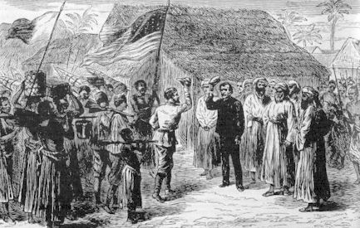
“Dr. Livingstone I presume.”

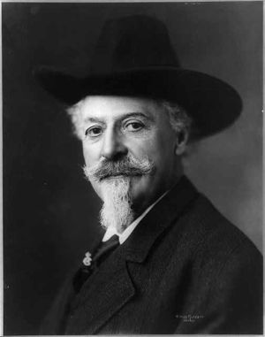

The following is the legacy of Buffalo Bill Cody as described by www.wikipedia.org:
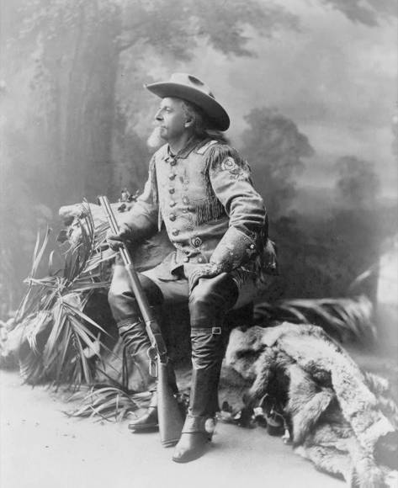
Frederick Cody (Buffalo Bill) got his nickname for supplying Kansas Pacific Railroad workers with buffalo meat. The nickname originally referred to Bill Comstock. Cody won the nickname from him in 1868 in a buffalo killing contest. He won 69 to 48.
In addition to his documented service as a soldier during the Civil War and as a Colonel, Chief of Scouts for the Army during the Plains Wars, Cody claimed to have worked many jobs, including as a trapper, bullwhacker, "Fifty-Niner" in Colorado, a Pony Express rider in 1860, wagonmaster, stagecoach driver, and even a hotel manager, but it's unclear which claims were factual and which were fabricated for purposes of publicity. He became world famous for his Wild West show.
Buffalo Bill was a rough-hewn outdoorsman, and pushed for the rights of American Indians and women. In addition, despite his history of killing the buffalo, he supported their conservation by speaking out against hide-hunting and pushing for a hunting season.
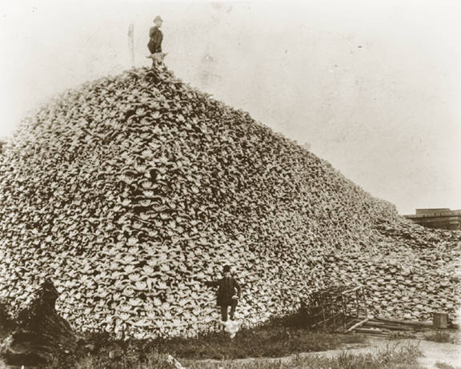
Buffalo Bill became so well known and his exploits such a part of American culture that his persona has appeared in many literary works as well as television shows and movies. Westerns were very popular in the 1950's and 60's. Buffalo Bill would make an appearance in most of them. As a character, he is in the very popular Broadway musical Annie Get Your Gun which was very successful both with Ethel Merman and most recently with Reba McEntire in the lead role. On television his persona has appeared on shows such as 'Bat Masterson' and even 'Bonanza'. His persona has been portrayed everywhere from an elder statesman to a flamboyant, selfserving exhibitionist.
Having been a frontier scout who respected the natives, he was a staunch supporter of their rights. He employed many more natives than just Sitting Bull, feeling his show offered them a better life, calling them "the former foe, present friend, the American.", and once said,
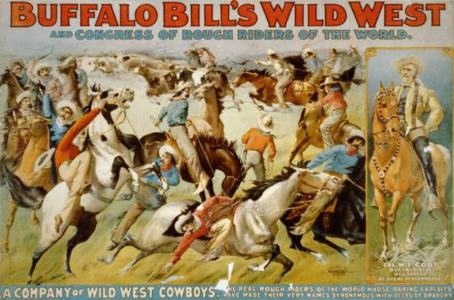
"Every Indian outbreak that I have ever known has resulted from broken promises and broken treaties by the government."

While in his shows the Indians were usually the "bad guys", attacking stagecoaches and wagon trains in order to be driven off by "heroic" cowboys and soldiers, Bill also had the wives and children of his Indian performers set up camp as they would in the homelands as part of the show, so that the paying public could see the human side of the "fierce warriors", that they were families like any other, just part of a different culture.
The city of Cody, Wyoming was founded in 1896 by Cody and some investors, and is named for him. It is the home of the Buffalo Bill Historical Center. Fifty miles from Yellowstone National Park, it became a tourist magnet with many dignitaries and political leaders coming to hunt. Bill did indeed spend a great amount of time in Wyoming at his home in Cody. However, he also had a house in the town of North Platte, Nebraska. This western Nebraska town is still home to "Nebraskaland Days," an annual festival including concerts and a large rodeo. His home in North Platte is both a museum, and a tourist destination for thousands of people every year.
Buffalo Bill became a hero of the Bills, a Congolese youth subculture of the late 1950s who idolized Western movies.
Read page 149 of your ‘Exploring Globalization’ textbook to give you additional perspective.

WHAT MAKES HERNAN CORTES A HISTORICAL HERO?

WHAT MAKES HERNAN CORTES A HISTORICAL VILLAIN?

Place the historical figure where you feel they fall on the hero – villain continuum.

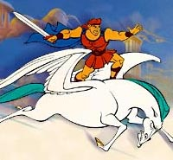
HERO
VILLAIN

WHAT MAKES SAMUEL de CHAMPLAIN A HISTORICAL HERO?

WHAT MAKES SAMUEL de CHAMPLAIN A HISTORICAL VILLAIN?

HERO
VILLAIN
Place the historical figure where you feel they fall on the hero – villain continuum.

WHAT MAKES HENRY MORTON STANLEY A HISTORICAL HERO?

WHAT MAKES HENRY MORTON STANLEY A HISTORICAL VILLAIN?

HERO
VILLAIN
Place the historical figure where you feel they fall on the hero – villain continuum.

WHAT MAKES BUFFALO BILL CODY A HISTORICAL HERO?

WHAT MAKES BUFFALO BILL CODY A HISTORICAL VILLAIN?

Place the historical figure where you feel they fall on the hero – villain continuum.

HERO
VILLAIN

