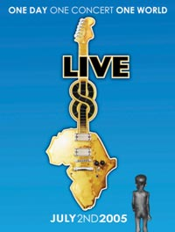
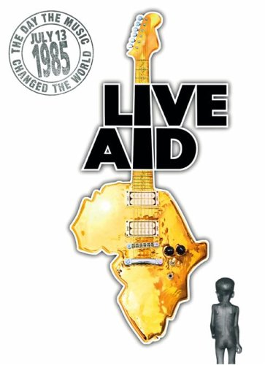

The 1984 - 1985 famine in Ethiopia was a significant famine in the history of Ethiopia. Drought and political instability contributed to the severity of the famine, which is estimated to have killed over one million people.
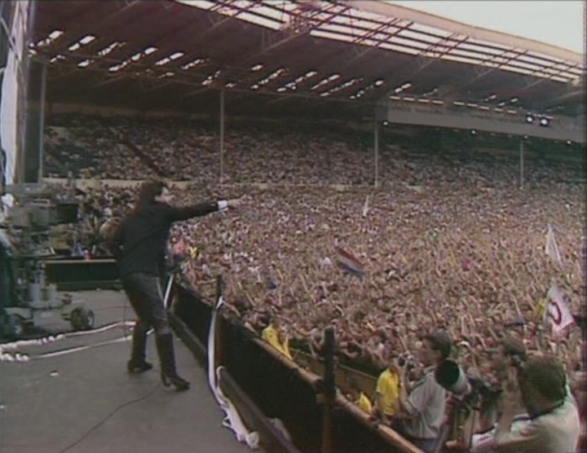
Media activity in the West, along with the size of the crisis, led to the January 1985 music video "We Are the World" (raised $63m) by American musicians. Candian artists released a song called “Tears are Not Enough” and British artists released “Do They Know its Christmas”. The July 1985 concert Live Aid (raised $100m), which elevated the international profile of the famine and helped secure international aid.

International view
Close to 8 million people became famine victims during the drought of 1984, and over 1 million died. In the same year, a BBC news crew was the first to document the famine, with Michael Buerk describing "a biblical famine in the 20th Century" and "the closest thing to hell on Earth". The report shocked Britain, motivating its citizens to bring world attention to the crisis in Ethiopia.

Live Aid
Live Aid, a 1985 fund-raising effort headed by Bob Geldof (who had also organized the charity group Band Aid the previous year), induced millions of people in the West to donate money and to urge their governments to participate in the relief effort. The event was one of the most widely-viewed television broadcasts in history, with over 1.5 billion viewers worldwide.
Live 8
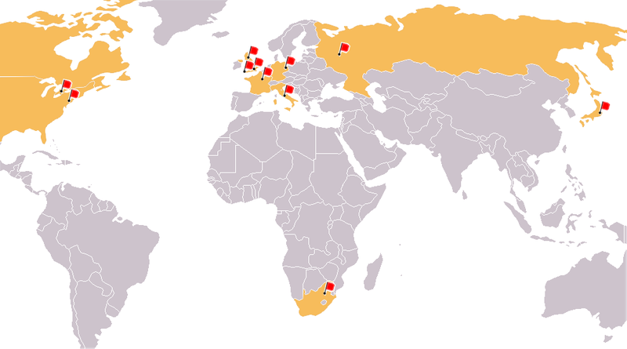
There were ten concerts held on 2 July 2005, most of them simultaneously. The first to begin was held at the Makuhari Messe in Japan, with Rize being the first of all the Live 8 performers. During the opening of the Philadelphia concert, Will Smith led the combined audiences of London, Philadelphia, Berlin, Rome, Paris and Barrie (outside Toronto) in a synchronised finger click. This was to represent the death of a child every three seconds, due to poverty.
Bob Geldof was at the event at Hyde Park in London, England and made numerous appearances on stage, including a performance of "I Don't Like Mondays". Some of these were also shown to other venues. Special guests appeared throughout the concerts, with Kofi Annan, the Secretary-General of the United Nations, and Bill Gates making a speech at the London show and Nelson Mandela appearing in the South African venue. Guest presenters, ranging from sports stars to comedians, also introduced acts.
Included in the line-up were Pink Floyd, reunited with former bassist/lyricist Roger Waters for the first time in over 24 years. The complete foursome had not performed together since a show at Earls Court in London on 17 June 1981.
The final event was held in Edinburgh on 6 July 2005 and went by the name Edinburgh 50,000 - The Final Push. It featured further performances from some of the artists from the other concerts, and was the closest of the eleven to the actual location of the G8 summit.

Listen to the three songs described on the previous page. Complete the following tasks:
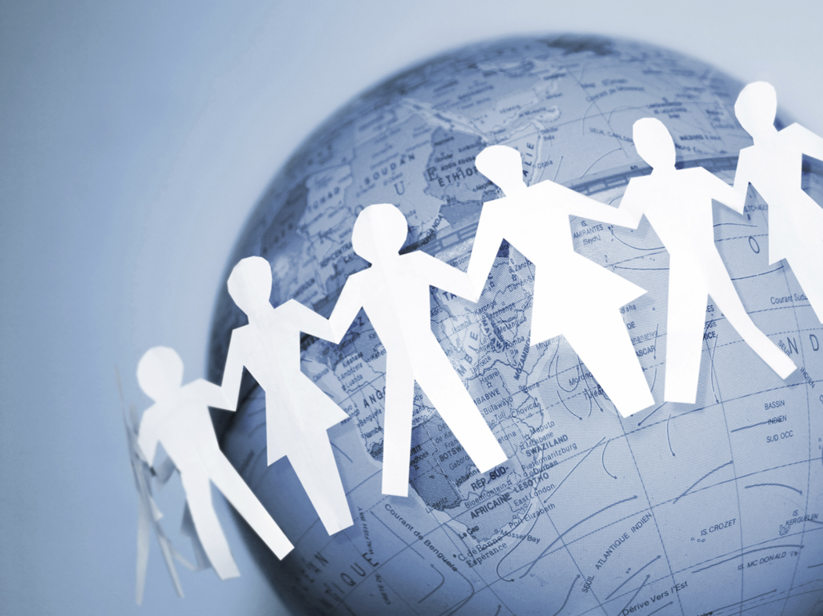
TASK ONE

Briefly describe the message each song.
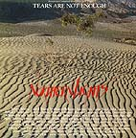
Tears are not Enough
Canadian Artists

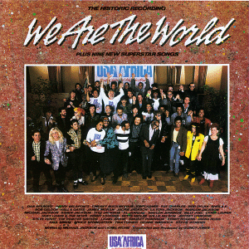
We are the World
American Artists

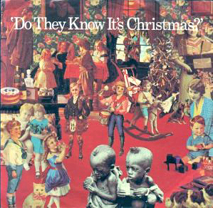
Do They Know Its Christmas
British Artists

TASK TWO

What song did you like the best? Rank them from 1 being the best to 3 being the worst.
Provide a brief rationale for each.

