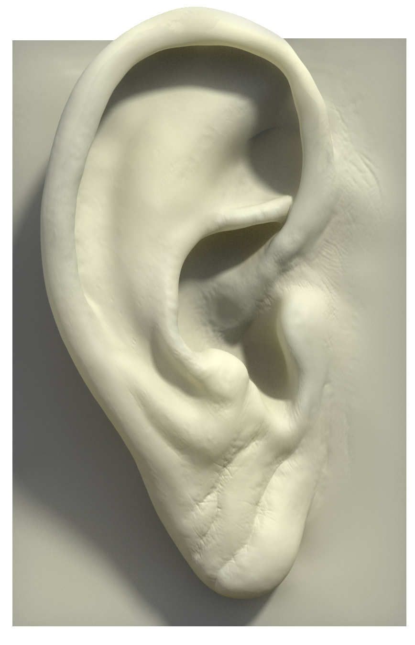

CAN YOU HEAR… HISTORY?

We hear political music (or music that deals with an issue) everyday. Do you hear the message or do you disregard the lyrics of music you listen to? Today, you have no choice! You are being put to the test, to see if you can pull valid information from music.

You are about to hear a selection of songs that all have to do with (in some way or another) imperialism. These songs come from a variety of genres and artists. You will get to see the lyrics for the song as it plays. The song will only play once, so you will need to being playing close attention. At the end of the song, you will have a minute to answer the following questions:

Song: Canada Needs You – Mike Ford

Approximate Year(s) Being Discussed: _________________ Era of Imperialism: ___________________________________

Evidence of Era:

The “tone or mood” of this song is: ______________________________________________________

Viewpoint About Imperialism Is Being Voiced:

Evidence:

Song: Great Nations of Europe – Randy Newman

Approximate Year(s) Being Discussed: _________________ Era of Imperialism: ___________________________________

Evidence of Era:

The “tone or mood” of this song is: ______________________________________________________

Viewpoint About Imperialism Is Being Voiced:

Evidence:

Song: Thanadelthur – Mike Ford

Approximate Year(s) Being Discussed: _________________ Era of Imperialism: ___________________________________

Evidence of Era:

The “tone or mood” of this song is: ______________________________________________________

Viewpoint About Imperialism Is Being Voiced:

Evidence:

Song: Living in a City of Immigrants – Steve Earle

Approximate Year(s) Being Discussed: _________________ Era of Imperialism: ___________________________________

Evidence of Era:

The “tone or mood” of this song is: ______________________________________________________

Viewpoint About Imperialism Is Being Voiced:

Evidence:

Song: Kenji – Fort Minor

Approximate Year(s) Being Discussed: _________________ Era of Imperialism: ___________________________________

Evidence of Era:

The “tone or mood” of this song is: ______________________________________________________

Viewpoint About Imperialism Is Being Voiced:

Evidence:

Other songs that could be used: Cortez the Killer – Neil Young, Deportee (Plane Wreck at Los Gatos) – Bruce Springsteen, Immigrant Workforce – Bedouin Soundclash

