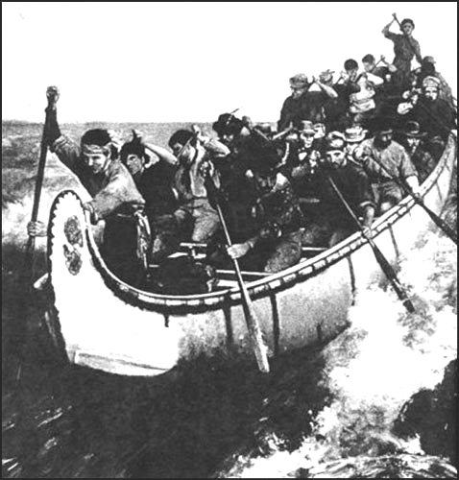
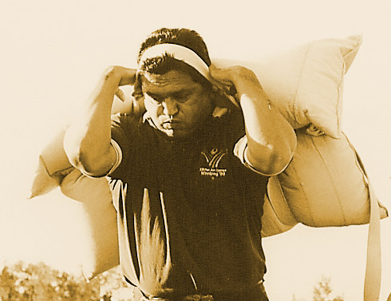

Opening Up the Continent

The voyageurs were the men who paddled the canoes or rowed the larger boats, which carried men and supplies over the rivers and lakes far to the north and west. They were usually French-Canadian or Métis, and they led a colorful but hard life. An army officer who traveled for Lachine to St. Joseph in 1798 wrote:
“No men in the world are more severely worked than are these Canadian voyageurs. I have known them to work in a canoe twenty hours out of twenty-four, and go at the rate during a fortnight or three weeks without a day of rest… They smoke almost incessantly, and sing peculiar songs, which are the same, their fathers and grandfathers and probably their great grandfathers sang before them… They rest from five to ten minutes every two hours, when they refill their pipes; it is more common for them to describe distances by so many pipes, than in any other way.
Many travelers wrote or told stories about voyageurs and commented on their bright women sashes, or ceintures flechees, and their rhythmic songs. But their daily routine, when on a trip, was extremely demanding and the trips often lasted as many as six or eight weeks. They were roused as early as two or three in the morning. Unless there were rapids just ahead, they started off without breakfast, which they did not get until about eight. The midday meal often consisted on nothing more than a piece of pemmican to chew as they continued to paddle. Then, usually between eight and ten in the evening, depending on the light, they made camp and ate their supper. Exhausted after the long days paddling, the men would enjoy a quiet smoke and then try to get some sleep. They lay on the ground with their heads under the overturned canoe, sheltered from the rain by a tarpaulin. They were constantly tormented by insect’s especially mosquitoes and black flies, but they got some relief by lighting smudges a few paces away. Their fires were piled high with damp moss or green leaves so that they gave off a dense, acrid smoke.
Apart from the long days of paddling and the many discomforts, there were also many real dangers, particularly at rapids and at the more difficult portages. Then the voyageurs, carrying two pieces of 40 kilograms each or helping to carry and inverted 300 kilogram cannot de maitre, had to struggle over rocks and through bogs and icy water. Many a voyageur died from injuries or from drowning. When this happened, his comrade buried him in the side of the trail and erected a crude wooden cross over his grave.
Suppose we accompany a fur brigade on its voyage from Montreal to the Saskatchewan. It is, shall we say, the spring of 1805. First we see trade goods and supplies, made up in ninety-pound bales or “pieces”, carted overland to Lachine, above the rapids. There they are loaded into twenty or more large canoes; which are to take us to Fort Williams at the head of the Lakes. These are the marvelous “canots de maitre” each about thirty-six feet in length, and constructed skillfully of birch bark over white cedar frames. In loading them the men take great care to see that every inch of space is used and that the weight is evenly distributed along the slender cedar framed. Each canoe is to carry a cargo of as much as six tons. Some space is left amidships, where the trader and ourselves, as passengers, are to sit in dignified idleness.
How about food for such a long trip? We see bag after bag of dried peas placed in the canoes. We are told that in the early days, when the traders sought most of their furs south of the Lakes, they established food depots and farms at Detroit and Michilimackinac. Here the mainstay was corn, turned into corn meal. But with the shift to the northwest it was clear that enough food would have to be carried to feed scores of hard-driving paddlers for a month or more. The answer was dried peas: it was light, compact, and “would stay with a man”.
At last everything is ready, and to the accompaniment of a chorus of adieus, the flotilla is off on its long voyage, gliding at surprising speed along the broad St. Lawrence. At once we are struck by the rhythmic, almost effortless paddling of our canoe men. They are not big men, these voyageurs, but they are muscular, robust and bursting with animal spirits. It is not
28

long before they are singing an old French chanson, as only voyageurs can sing it. They seem as so many have reported them, the happiest and most carefree men in the world.
A few hours later our canoes swing into the Ottawa and our crews turn their thoughts to the tasks ahead. Speed records are to be broken this trip, they tell us, and so we may expect hair-raising adventures, far more than we shall have space to relate.
After a week with these astounding fellows, it has been one long battle against nature, we can report in the words of an observer: “No men are…more capable of enduring hardship or are more good-humored under privations, toiling up rivers or coasting lakes; encamping at night on the borders, gossiping around their fires, and bivouacking in the open air”. Now we are pushing along the north shore of Lake Huron, our canoe men keeping up the same driving pace. Sometimes they paddle twenty hours a day and make as much as seventy miles, resting only every two hours to refill their pipes (they smoke almost incessantly, using their own strong “tabac Canadien”). We ask ourselves (as we lie back in the comfort) how many such days we could stand: to be up at three, paddle till eight, breakfast, paddle till after dark, then supper. No wonder our hungry voyageurs smack their lips over their huge bowls of pea soup: after their hours of ton, they find it a meal fit for a king.
At last we reach Fort William, the company’s “half-way” house. Here the Montreal merchants who have made the trip with us meet their wintering partners, conferences are held and all the intricate problems of the trade are ironed out. But the two weeks we spend at this fur traders’ capital are not given over entirely to business. Trade has been booming, profits are high; there are many stories to tell (to accompaniment of much drinking) of home, the Hudson’s Bay men have been everywhere outwitted. The result is an almost continuous round of uproarious celebrations in which our canoe men, scorning the chance for a well-earned rest, join with gusto.
All too soon this annual meeting of the fur trade brotherhood is over. The large Montreal canoes, laden with the winter’s catch of furs, are homeward bound; and we are off for the distant northwest. Trade goods and supplies have been transferred to smaller canoes, “les canots du nord”. About twenty-four feet long and light in weight, they are more easily handled in the rivers and over the portages out west of the Lakes. Yet these frail craft carry a ton and a half of freight and four or five canoe men and traders. Our food is now mostly corn meal to be supplemented later by wild rice.
Our canoes respond amazingly to the master touch of the paddlers, and in a remarkably short time we have negotiated the Kaministiquia River, then a network of rivers and lakes to Rainy River and Lake of the Woods. Now we enter the treacherous Winnipeg River. Rapids, waterfalls, rock! Tragedy enters the scene when a canoe man loses his life shooting the rapids. We reach the Seven Sisters Falls where as Alexander Mackenzie wrote there are “seven portages in so short a space that they all can be seen at the same moment”. Our men undertake every portage with the bursting energy of boys in an obstacle race. Two of them carry the canoe; each of the others swings one bale to his back, holding it in position by a tumpline around it and across his forehead. He then throws another bale on top of it crosswise and sets off at the dogtrot.
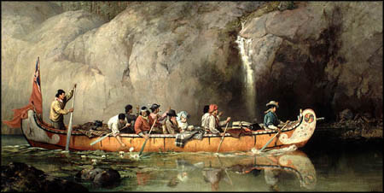
When we reach the open waters of Lake Winnipeg the men burst into a song of triumph; but we press on to the mouth of the Red River and up to the forks of the Red and the Assiniboine, the site of the present Winnipeg. Here, at the company’s chief western food depot, we take on a supply of pemmican. This food, we are told, is the mainstay of the traders west of the Lakes. It is buffalo meat, which has been dried, pounded into flakes and mixed with hot fat. Packed in bags of buffalo skin, it will keep for years.
We ascend the Assiniboine to Portage La Prairie, the prairie portage, where we cross to Lake Manitoba, then north to Lake Winnipegosis. Eventually, to the joy of all, we reach our goal, a post on the Saskatchewan River. Here we must bring our imaginary journey to an end, stouthearted voyageur. He could, we know, have taken us on – on to the Peace River to the Athabasca country, to the very limits of the continent.”
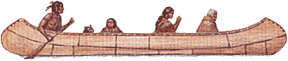
NAME: ____________________________

The Voyageurs - Opening up the Continent

- Briefly who the voyageurs were and what they did?
___________________________________
___________________________________ ___________________________________
___________________________________
___________________________________
___________________________________

- Briefly describe a typical day in the life of a voyageur?
___________________________________
___________________________________
___________________________________ ___________________________________
___________________________________

- The voyageurs often used “smudges” to ward off the insects that constantly tormented them. What is a smudge?
___________________________________
___________________________________
___________________________________
___________________________________

- The life of the voyageur was often very dangerous. What dangers did the voyageur face?
___________________________________
___________________________________ ___________________________________
___________________________________
___________________________________
___________________________________

- What type of canoe was used from Montreal to Fort William? Descirbe this canoe.
___________________________________
___________________________________
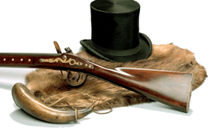
___________________________________
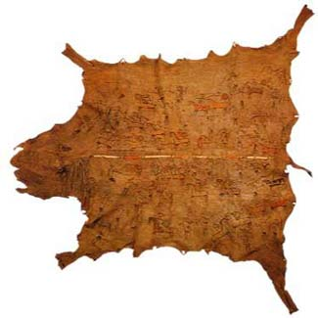
___________________________________

- What type of food did the voyageurs use on their trip from Montreal to Fort William? Why was this food used?
___________________________________
___________________________________
___________________________________
___________________________________

- An exchange and conference takes place at Fort William. What is the exchange? What is the conference about?
___________________________________
___________________________________
___________________________________
___________________________________

- From Fort William, the remainder of the trip to the northwest is completed in the Northern canoes. Describe a Northern canoe.
___________________________________
___________________________________
___________________________________
___________________________________

- On the trip to the northwest, three main foods were used by the voyageurs. Name the three foods and explain why these foods were used?
___________________________________
___________________________________
___________________________________
___________________________________

- It was often necessary for the voyageurs to portage. Explain what a portage is?
___________________________________
___________________________________ ___________________________________
___________________________________

___________________________________
___________________________________

Voyageurs - Opening up the Continent – Answer Key

1. Briefly who the voyageurs were and what they did?
French-Canadian or Métis men paddled canoes to carry men and supplies over the rivers and lakes to the north and west.

2. Briefly describe a typical day in the life of a voyageur?
They would work in a canoe 20 hours a day for 2 – 3 weeks. They got up at 2 or 3 a.m. to start the day. They ate pemmican for breakfast and lunch. They smoked a pipe all day, sang peculiar songs. They ate pea soup for supper, slept on the ground for a few hours.

3. The voyageurs often used “smudges” to ward off the insects that constantly tormented them. What is a smudge?
A smudge is a fire piled high with damp moss or green leaves to give off a dense, acrid smoke to keep mosquitoes and insects away.

4. The life of the voyageur was often very dangerous. What dangers did the voyageur face?
Many voyageurs died from injuries during a portage or from drowning.

5. What type of canoe was used from Montreal to Fort William? Describe this canoe?
Canots de maitre – This was a 36 foot birch canoe that could carry 6 tonnes of cargo.

6. What type of food did the voyageurs use on their trip from Montreal to Fort William? Why was this food used?
The voyageurs ate dried peas because they were light, compact, and “would stay with a man”.

7. An exchange and conference takes place at Fort William. What is the exchange? What is the conference about?
The Montreal merchants and their wintering partners meet to iron out the problems of the fur trade.

8. From Fort William, the remainder of the trip to the northwest is completed in the Northern canoes. Describe a Northern Canoe?
The Northern Canoe was 24 feet long; light weight, but could carry over a ton of freight and four or five canoe men.

9. On the trip to the northwest, three main foods were used by the voyageurs. Name the three foods and explain why these foods were used?
The three main foods were dried peas, cornmeal, and pemmican because they were light weight and lasted a long time.

10. It was often necessary for the voyageurs to portage. Explain what a portage is?
A portage is when voyageurs would carry their canoe and its cargo around a waterfall or over land to another river.

