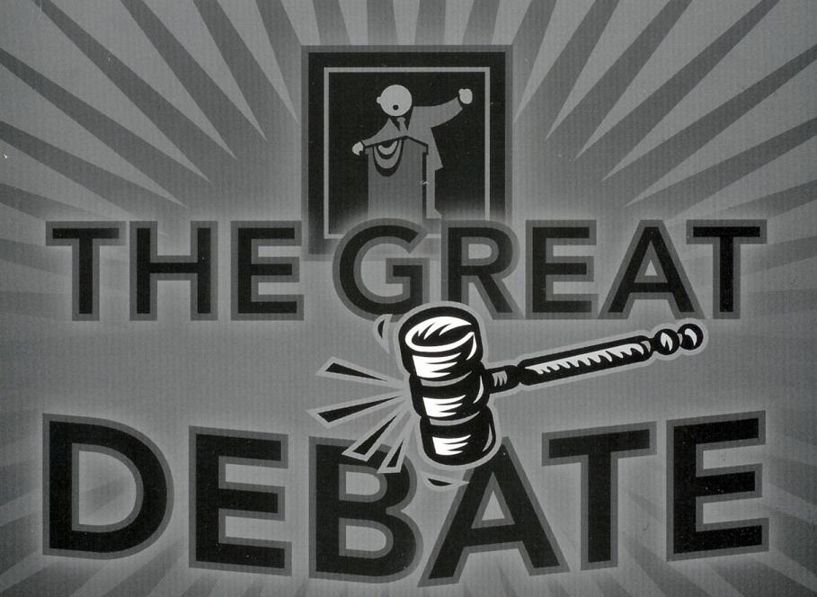

Becoming a Great Debater
- Review terminology – ( SS10)
- Expanded terminology
- Logical Fallacies – P. 77-79

- Watch Great Debaters –
  - Watch for thesis statement
  - Strong elements of debating

- Great Debate List
  - Choose topics and build debates
  - Classmates act as judges (6 judges for each debate).
  - 3 people on each debate team
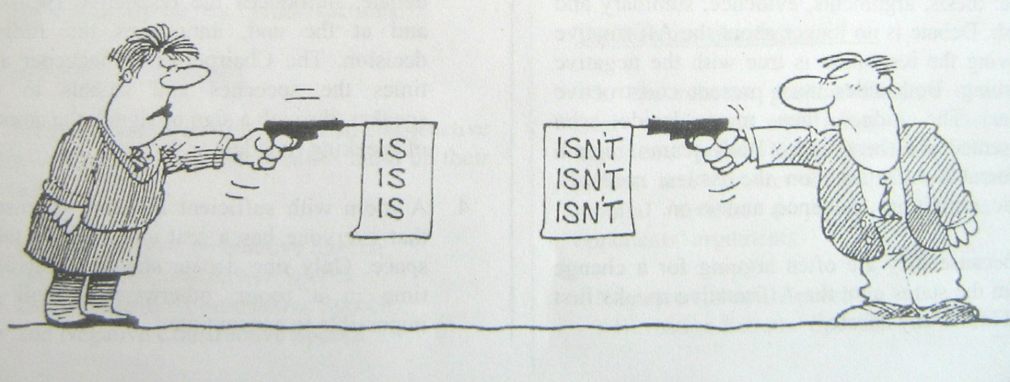

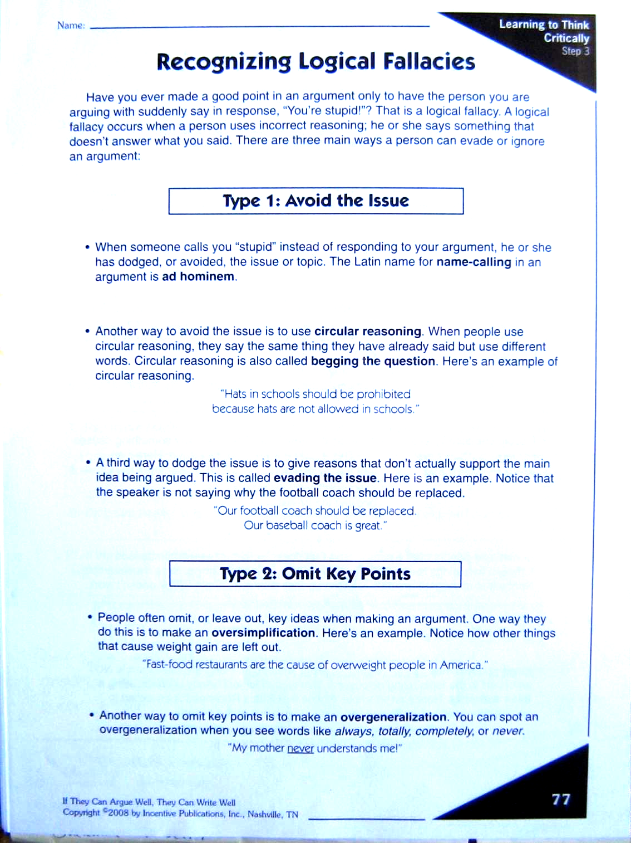

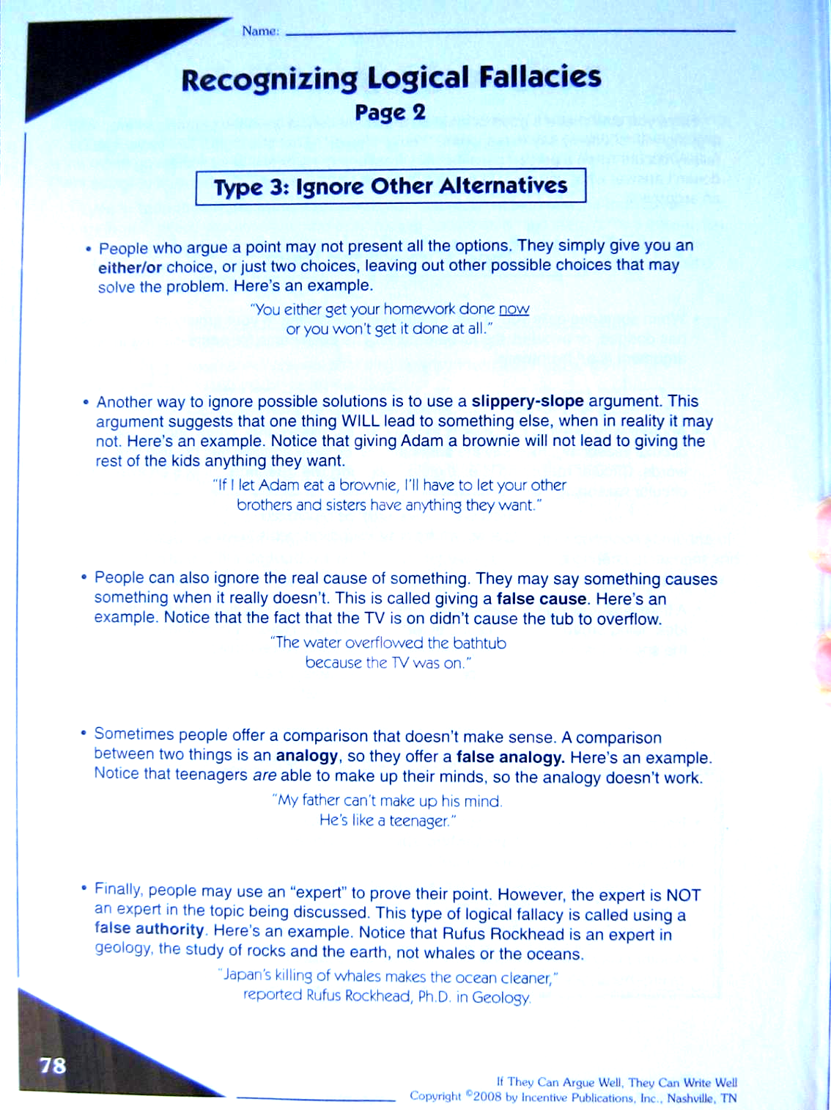

The Refutation Chart
Method of Rebuttal Points s

Challenge the problem Opponent doesn’t understand the real issue
Opponent doesn’t deal with the real issues

Challenge the analysis Opponent overlooked important parts of the issue
Opponent doesn’t understand the consequences
Opponent looking at the issue from the wrong angle
Opponent’s argument based on false/faulty assumptions

Problem with authority of evidence Person is not specialized in the topic
Person’s bias is questionable
Person’s research is not conclusive in its results
Person’s research methods are questionable

Problem with statistic Statistic of too small a sample group
Statistic of too narrow a sample group
Statistic inconsistent with other findings
Statistic used biased questions/wording
Statistic is irrelevant

Corollary argument Demonstrate opposite results from argument of opponent
No relationship (no cause and effect)

Minimization/Mitigation Opponent used extremes to prove their case
Opponent only used isolated incidents
“So what?” The benefits outweigh consequences
Impact actually good, not negative

Special arguments Opponent is using circular reasoning
Opponent is appealing to prejudice
Opponent is appealing to emotional sentiments
Opponent is appealing to habit/ritual
Opponent is contradicting previous speech
Opponent’s principles lead to unwanted precedent
Opponent’s suggestion of only two options is false

Basic Speech Mechanics

Physical mannerisms of your voice and body can either distract people or intensify their enjoyment of your speech. Consider:
Stance
- Stand firmly on two feet – do not lean or slouch. Avoid leaning on chairs and tables.
- Hands – keep clasped in front of you, place them on the lectern, or move them for useful and effective gestures. Keep them out of your pockets

Appearance
- Dress neatly and attractively
- Appearance and dress can influence your audience no matter who is in attendance

Look at the Audience
- Do not look at only one or two people or only one side of your audience. Your eyes should constantly rove over the entire group
- Do not keep your eyes locked on your notes – this is a certain way to lose the attention of your audience

Volume and Tone
- Speak loudly enough for all to clearly hear. Do not be afraid to use extra volume to emphasize.
- In general, vary the volume and pace of your speaking according to what you want to stress.
- Use passion, calm, aggression, and meekness to stress your points or defuse your opponents.

Pace of Speaking
- Do not speak too quickly (often an issue if you are reading your material)
- Speak slowly when you want to emphasize a point
- Varying your pace is important

Pause
- The finest speakers use pauses to emphasize something. The pause can be in the middle or at the end of a sentence.

Use of Questions
- Use of rhetorical questions involves your audience in your speech.
“Ladies and Gentlemen, what is the greatest problem facing Native groups today? Is it lack of education? Is it lack of opportunity? Is it a cultural protection issues? Is it the apathy of the government? It is none of these. It is rather...”

Facial Expressions
- You can do a great deal with your eyes and smile; a smile early in your speech can do wonders.
- Set the mood of your talk with the way you look at the audience.

Gestures
- Emphasis and expression with the hands is another technique found with all good speakers.
- Gestures should be relevant and varied. They should never be distracting or annoying.

Nervousness
Ways to reduce nervousness include:
- Knowing what you are going to say. Thorough preparation usually eliminates all nervousness except the momentary feeling at the start of the talk.
- Taking a few deep breaths before standing to speak
- Relaxing in the knowledge that every speaker (even the greatest ones) get nervous.
- Most nervousness does NOT show as much as you think it does. Just keep talking as though it was not there.

Notes
- Do not use large cumbersome, distracting sheets of paper. Small cards are recommended.
- Do not worry about people knowing that you need to rely on notes - but keep your head up as much as possible. Your voice will carry better.
- Do not write your speech out word for word (you’ll be too tempted to read it). Instead, write down the general headings and specific stats or quotes you may need.

Humour
- Entertaining speeches require careful planning. One can be humourous and entertaining and still have a serious and worthwhile message. Keep the humour relevant and well suited to the audience. Avoid sarcasm.
- It takes skill and thought to use humour well. Be careful not to offend the judges. Remember, what seems funny to a student-debater could be perceived as not funny or even offensive by a judge who is somewhat older.

Read Your Audience
- Who are the judges? Will they understand your current pop culture reference? Are they wearing suits or casual clothes? Can you hypothesis what their attitudes and biases might be?
- Although your answers will only lead to generalizations, the composition of the judging panel and the audience can play a role in the type of comments you make.
- Consider the tone of the debate. Is it serious or lighter in tone? Should you make emotional appeals or logical approaches?
- Are they frowning or smiling during the debate? Are they following you, or are they looking confused? Do you need to change something about your debate?

CLASH CARD
When you hear your opponents’ plan, ask the following questions:
- How much will it cost?
- Where will the funds come from?
- Does it solve the need for change?
- Could this problem be solved with a more simple solution?
- Is there proof this plan will work?
- How will the public react or be affected by this idea?
- Will the plan be consistent with Canada’s morals and legal system

When Your Opponents Do the Unexpected
Areas for clash focus:
- Is the definition legitimate?
- Can the wording of what was said be reworded in your favour?
- What practical problems will be associated with this?
- Is this really a significant change?
- What key point (of what was said) can be attacked?
- How much will it cost?
- Are they trying to avoid the real issues?
- Follow the argument to the extreme... what are the ramifications?
- Apply the slippery slope and do some fear mongering if necessary
- Apply the emotional appeal: will this affect children or the elderly?

Social 20 - The Great Big Debate Topics List!

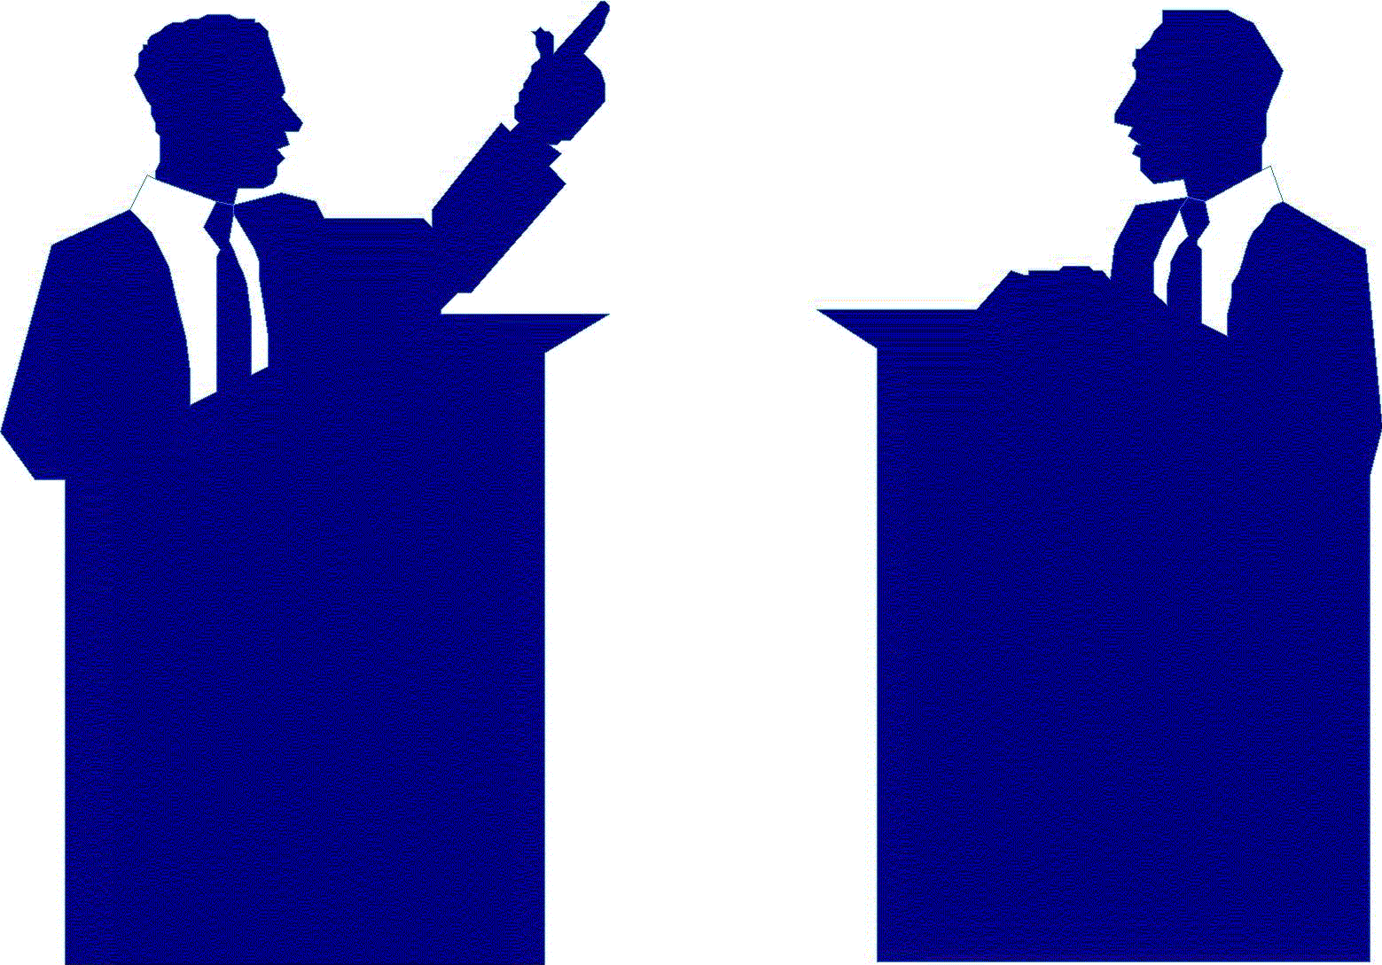
- Same sex schools help children learn better than co-ed schools.
- Non-human animals deserve the more rights than what they currently have.
- Gay couples should be given the same legal rights as heterosexuals in adopting children.
- The age to drive a vehicle should be raised to 18.
- Violent video games do not promote violent behaviour.
- Genetically modified foods should be banned.
- Assisted suicide should be legalized.
- Boxing and UFC should be banned.
- Random breathalyser tests for drivers are good idea.

- Marijuana should be legalized.
- Young people should be subjected to night-time curfews as a way to reduce crime.
- Children should not be allowed to work in the performing arts or professional sports.
- Sexual education programs should be mandatory and include the distribution of condoms.
- The Confederate flag and the swastika should be banned from public display.
- Physical force (including execution) is never a justifiable method of punishing criminals.
- Physical force is never a justifiable method of punishing children.
- The legal age for drinking alcohol should be raised to 19 across Canada.
- School students should face mandatory drug-tests.
- Feminism is no longer relevant.

- The government should censor lyrics of songs that are violent or expletive.
- Laws should be passed to limit gun ownership further.
- Those under the age of 17 should not be allowed to own or use cellphones.
- Parents should be held morally and legally responsible for the actions/needs of their children.
- Parenthood should be seen as a privilege not as a right (males at age 16 will be given a vasectomy and it will be reversed when a couple can prove they will be responsible parents).
- Prostitution should be fully legalized, and monitored through government run brothels.
- The province of Quebec should secede from Canada.
- A mandatory maximum salary should be imposed by governments.
- Schools should require their students to wear a school uniform.
- Men found guilty of sex crimes against children should be chemically castrated.

- There should be a full ban on the advertising, selling, and smoking of tobacco.
- Mankind should not continue to invest in the exploration of space.
- Medical research involving the use of human stem cells should be permitted.
- Schools school not have the right to search students’ lockers.
- The government should permit assisted suicides.
- Unhealthy foods should be banned from schools.
- Canada should ban violent video games.
- Canada should ban the keeping of animals in zoos.
- Canada and the United States should merge together.
- Canada should practice isolationism and become as self-sufficient as possible

Understanding the Steps of Debate
3rd Speaker
- Offers final rebuttals of all affirmative claims
- Last chance to work in a final contention
- Gives final persuasive summary

2 MINUTES

Open Discussion Period –
Led by the affirmative side, any of the debaters can jump in and talk at any time. 5 MINUTES
1st Speaker
- Rebuttal
- Leads into the FIRST contention
- Backs contention up with evidence
2 MINUTES

- Records Negative Contentions on Board
2.
3.
4.
7.
8.
2nd Speaker
- Rebuttal
- Leads into the SECOND contention
- Backs contention up with evidence
2 MINUTES

- Records Affirmative Contentions on Board

2nd Speaker
- Rebuttal
- Leads into the SECOND contention
- Backs contention up with evidence
2 MINUTES

- Records Negative Contentions on Board

1.
Debates take the floor, shake hands, and take their seats

Affirmative Side The Opposed

1st Speaker
- States Proposition
- Leads into the FIRST contention
- Backs contention up with evidence
2 MINUTES

- Records Affirmative Contentions on Board

5.

6.

3rd Speaker
- Offers final rebuttals of all of the negative side’s claims
- Last chance to work in a final contention
- Gives final persuasive summary

2 MINUTES

Debaters shake hands with their opposition, and return to their seats.

- States any Counterarguments
- Offers final Rebuttals of all Negative claims
- Gives Final Persuasive Summary
9.

