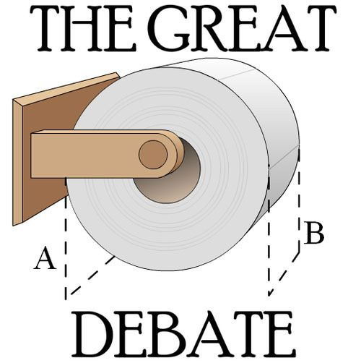

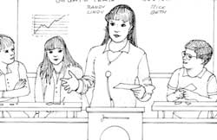

PLEASE, DO NOT WRITE ON THIS PACKBOOKLET.
Grading a Student’s Persuasive Essay
Directions: Read this student persuasive essay once. Give it a quick score by circling one of the numbers below.
1 is “terrible.” 3 is “average.” 5 is “excellent.”
1 2 3 4 5

Let’s Get Out and Eat Out!
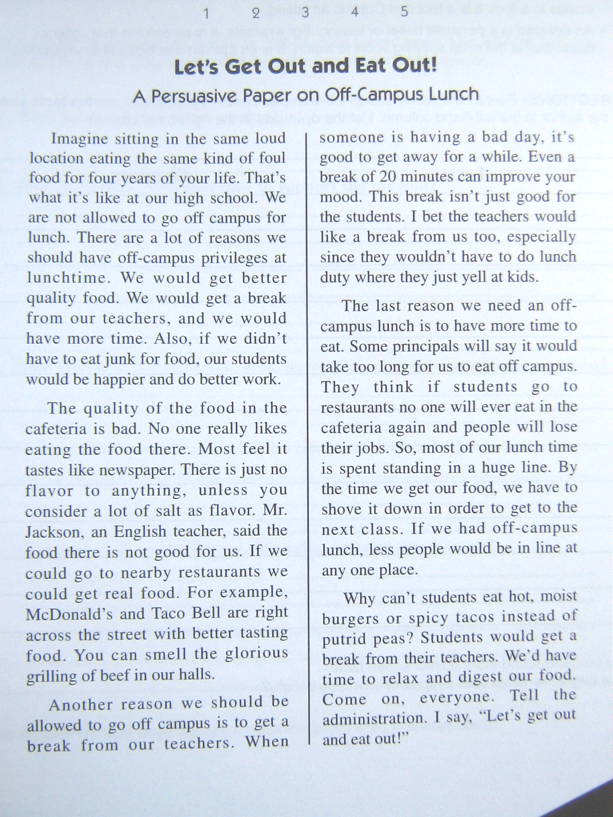
A Persuasive Paper on Off-Campus Lunch
Imagine sitting in the same loud location eating the same kind of foul food for four years of your life. That’s what it’s like at our high school. We are not allowed to go off campus for lunch. There are a lot of reasons we should have off campus privileges at lunch time. We would get better quality food. We would get a break from out teachers, and we would have more time. Also, if we didn’t have to eat crap for food our students would be happier and do better work.
The quality of the food in the cafeteria is bad. No one really likes eating the food there. Most feel it tastes like newspaper. There is just no flavour to anything, unless you consider a lot of salt as flavour. Mr. Jackson, an English teacher, said the food there is not good for us. If we could go to nearby restaurants we could get real food. For example, McDonald’s and Taco Bell are right across the street with better tasting food. You can smell the glorious grilling of beef in our halls.
Another reason we should be allowed to go off campus is to get a break from our teachers. When someone is having a bad day, it’s good to get away for a while. Even a break of 20 minutes can improve your mood. This break isn’t just good for the students. I bet the teachers would like a break from us too especially since they wouldn’t have to do lunch duty where they just yell at kids.
The last reason we need an off campus lunch is to have more time to eat. Some principals will say it would take too long for us to eat off campus. They think if students go to restaurants no one will ever eat in the cafeteria again and people will lose their jobs. So, most of our lunch time is spent standing in a huge line. By the time we get our food we have to shove it down in order to get to the next class. If we had off campus lunch, less people would be in line at any one place.
Why can’t students eat hot, moist burgers or spicy tacos instead of putrid peas? Students would get a break from their teachers. We’d have time to relax and digest our food. Come on everyone. Tell the administration. I say, “Let’s get out and eat out!”

Glossary of Debate Terms:

affirmative side – side that supports the proposition/resolution
B.I.R.T. – a commonly used abbreviation for “Be it resolved that...”, a standard phrase which proceeds a debate resolution
case – all of the elements that comprise a team’s strategic approach to a resolution
concede – to admit that someone else is right
constructive Speech – a speech in a debate when a debater presents new contentions to build their cases
contention – a strong statement to support one side of an argument
counterargument – an opposing argument
debate – to argue both sides of a topic
evidence – facts and examples that prove
fact – something proven to be true
fallacy – something that is not true
forgotten actors – a method to generate arguments. Consider all the individual people, groups, communities, organizations, institutions, businesses, and governments possibly affected by the resolution
LEET – a way of remembering the parts of an argument/contention: Label, Explanation, Evidence, Tie-back
logic – a method of proving an argument to be true. Logic uses clear, defensible statements that work together to create a point. The statements cannot rest on points unproven (fallacies) or on themselves (circular reasoning)
opinion – a feeling or belief
opposed/negative side – side that opposes the proposition/resolution
persuade – to try to convince someone
rebuttal – a response to a counterargument
refutation – the process of proving that the other teams argument/contention is incorrect or illogical
resolution / proposition – the subject to be resolved through the debate
resolve – make a firm decision to do something
SPLEEM – the acronym for remembering the types of arguments you can use in a debate: S - social, P - political, L - legal, E - economic, E - environmental, M - moral
status quo – a Latin term that refers to the present established system
thesis – the main point a team is proving. Both the negative and affirmative have a case line statement (or thesis)
Effective Word Choice for Debaters
To counter your opponent’s contention, use the following four-step method:
- “They say that ...” (briefly restate the opponent’s point).
- “But we disagree that ...” (briefly state that you disagree).
- “Because ...” (give a strong and relevant counterargument).
- “Therefore...” (explain to the audience how this wins your argument and why they should agree).

Words and Phrases to Avoid in a Debate:
totally bad like awesome
stuff things good you know
uh whatever chill very
dude for real stupid really
always every time never impossible

Words and Phrases to Persuade or Convince in a Debate:
as the evidence shows abolish avoid
for example powerful superior
in this case overcome mobilize
highly recommended prevent change
at this moment tradition urgent
take a bold new step guarantee eliminate
a proven method patriot(ism) honour
scientifically verified focus ensure
without a doubt values improve
cannot justify justice society
the truth is that oversimplify exaggerate
such an exaggeration breakthrough ultimate
one mustn’t confuse progress duty
the research is clear inherent crisis
the time has come restore act
one cannot deny call upon national interest
Understanding the Steps of Debate
3rd Speaker
- Offers final rebuttals of all affirmative claims
- Last chance to work in a final contention
- Gives final persuasive summary

2 MINUTES

Open Discussion Period –
Led by the affirmative side, any of the debaters can jump in and talk at any time. 5 MINUTES
1st Speaker
- Rebuttal
- Leads into the FIRST contention
- Backs contention up with evidence
2 MINUTES

- Records Negative Contentions on Board
2.
3.
4.
7.
8.
2nd Speaker
- Rebuttal
- Leads into the SECOND contention
- Backs contention up with evidence
2 MINUTES

- Records Affirmative Contentions on Board

2nd Speaker
- Rebuttal
- Leads into the SECOND contention
- Backs contention up with evidence
2 MINUTES

- Records Negative Contentions on Board

1.
Debates take the floor, shake hands, and take their seats

Affirmative Side Negative Side

1st Speaker
- States Proposition
- Leads into the FIRST contention
- Backs contention up with evidence
2 MINUTES

- Records Affirmative Contentions on Board

5.

6.

3rd Speaker
- Offers final rebuttals of all of the negative side’s claims
- Last chance to work in a final contention
- Gives final persuasive summary

2 MINUTES

Debaters shake hands with their opposition, and return to their seats.

- States any Counterarguments
- Offers final Rebuttals of all Negative claims
- Gives Final Persuasive Summary
9.

Social 10 - The Great Debate Topics List!

- The American invasion of Iraq is modern imperialism.
- African disputes and conflicts should be handled by African countries themselves, rather than by external international organizations.
- The Catholic Church should change its current position of forbidding the use of contraception.
- The imposition of sanctions on nations is the best way to end child labour.
- Former colonial powers should pay reparations to former colonies for their past activities.
- As there is a growing consensus that global climate changes are being caused by environmental pollution, especially by greenhouse gases, more urgent action needs to be taken to halt this trend.
- Transnational corporations do more harm than good.
- Canada needs to provide more leadership towards meeting the United Nations Millennium Development Goals.
- Outsourcing (and “off-shoring”) is a positive phenomenon.
- There should be an international minimum wage.

- There a global crisis of overpopulation, so, families around the world should have a maximum of 3 children.
- Companies who benefit from the use of sweat-shop labour, child labour and slave labour be barred from operating in Canada.
- The government should use taxation incentives or policy to encourage the use of cars which are not fuelled by petroleum products.
- There should be an international organization that censors material on the World Wide Web.
- The United States is the greatest threat to world security.
- Canada, the United States, and should join together to form a new nation.
- The oil industry in Alberta should be taxed more heavily.
- The United Nations should be judged as a failure.
- We should press for the abolition of the power of veto held by the permanent members of the Security Council.
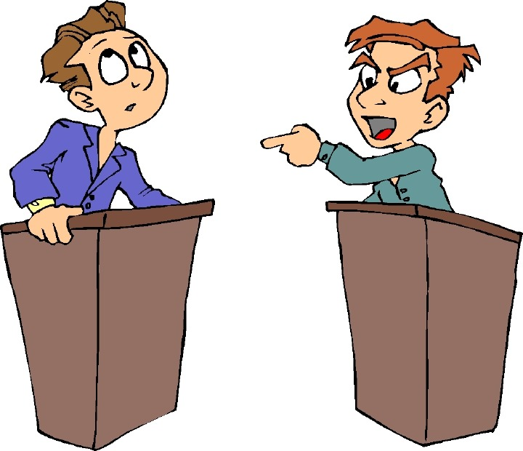
- The CRTC rules that require specific amounts of Canadian content in Canadian radio and TV programming should be ended.

- Civil disobedience should be seen as a justifiable way to accomplish a goal.
- Technology isolates and divides groups within society.
- Water should be treated as an economic commodity (product).

Basic Speech Mechanics

Physical mannerisms of your voice and body can either distract people or intensify their enjoyment of your speech. Consider:
Stance
- Stand firmly on two feet – do not lean or slouch. Avoid leaning on chairs and tables.
- Hands – keep clasped in front of you, place them on the lectern, or move them for useful and effective gestures. Keep them out of your pockets

Appearance
- Dress neatly and attractively
- Appearance and dress can influence your audience no matter who is in attendance

Look at the Audience
- Do not look at only one or two people or only one side of your audience. Your eyes should constantly rove over the entire group
- Do not keep your eyes locked on your notes – this is a certain way to lose the attention of your audience

Volume and Tone
- Speak loudly enough for all to clearly hear. Do not be afraid to use extra volume to emphasize.
- In general, vary the volume and pace of your speaking according to what you want to stress.
- Use passion, calm, aggression, and meekness to stress your points or defuse your opponents.

Pace of Speaking
- Do not speak too quickly (often an issue if you are reading your material)
- Speak slowly when you want to emphasize a point
- Varying your pace is important

Pause
- The finest speakers use pauses to emphasize something. The pause can be in the middle or at the end of a sentence.

Use of Questions
- Use of rhetorical questions involves your audience in your speech.
“Ladies and Gentlemen, what is the greatest problem facing Native groups today? Is it lack of education? Is it lack of opportunity? Is it a cultural protection issues? Is it the apathy of the government? It is none of these. It is rather...”

Facial Expressions
- You can do a great deal with your eyes and smile; a smile early in your speech can do wonders.
- Set the mood of your talk with the way you look at the audience.

Gestures
- Emphasis and expression with the hands is another technique found with all good speakers.
- Gestures should be relevant and varied. They should never be distracting or annoying.

Nervousness
Ways to reduce nervousness include:
- Knowing what you are going to say. Thorough preparation usually eliminates all nervousness except the momentary feeling at the start of the talk.
- Taking a few deep breaths before standing to speak
- Relaxing in the knowledge that every speaker (even the greatest ones) get nervous.
- Most nervousness does NOT show as much as you think it does. Just keep talking as though it was not there.

Notes
- Do not use large cumbersome, distracting sheets of paper. Small cards are recommended.
- Do not worry about people knowing that you need to rely on notes - but keep your head up as much as possible. Your voice will carry better.
- Do not write your speech out word for word (you’ll be too tempted to read it). Instead, write down the general headings and specific stats or quotes you may need.

Humour
- Entertaining speeches require careful planning. One can be humourous and entertaining and still have a serious and worthwhile message. Keep the humour relevant and well suited to the audience. Avoid sarcasm.
- It takes skill and thought to use humour well. Be careful not to offend the judges. Remember, what seems funny to a student-debater could be perceived as not funny or even offensive by a judge who is somewhat older.

Read Your Audience
- Who are the judges? Will they understand your current pop culture reference? Are they wearing suits or casual clothes? Can you hypothesis what their attitudes and biases might be?
- Although your answers will only lead to generalizations, the composition of the judging panel and the audience can play a role in the type of comments you make.
- Consider the tone of the debate. Is it serious or lighter in tone? Should you make emotional appeals or logical approaches?
- Are they frowning or smiling during the debate? Are they following you, or are they looking confused? Do you need to change something about your debate?

CLASH CARD
When you hear your opponents’ plan, ask the following questions:
- How much will it cost?
- Where will the funds come from?
- Does it solve the need for change?
- Could this problem be solved with a more simple solution?
- Is there proof this plan will work?
- How will the public react or be affected by this idea?
- Will the plan be consistent with Canada’s morals and legal system

When Your Opponents Do the Unexpected
Areas for clash focus:
- Is the definition legitimate?
- Can the wording of what was said be reworded in your favour?
- What practical problems will be associated with this?
- Is this really a significant change?
- What key point (of what was said) can be attacked?
- How much will it cost?
- Are they trying to avoid the real issues?
- Follow the argument to the extreme... what are the ramifications?
- Apply the slippery slope and do some fear mongering if necessary
- Apply the emotional appeal: will this affect children or the elderly?

